Traverse City

The Traverse City Unit manages state forest lands in Benzie, Grand Traverse, Kalkaska, Leelanau, and Manistee Counties.

The Traverse City Unit’s compartment review for YOE 2007 will be held December 13, 2005 for Benzie, Grand Traverse, Leelanau, and Manistee Counties with an open house on November 29th. The compartment review for Kalkaska County will be held December 14, 2005 with an open house on November 30th.

You can reach the Unit Manager, Dave Lemmien at 231-922-5280 extension 6840, or send an e-mail to him at DNR-TraverseCity-FMU@michigan.gov.

The Traverse City Unit manages approximately 330,000 acres of State land. Of the 330,000 acres, Kalkaska County encompasses almost 171,000 of those acres. Headquarters for the unit is located in Traverse City with a satellite field office in Kalkaska and one fire officer stationed at the Platte River Fish Hatchery.

This unit manages: 16 campgrounds, 5 snowmobile trails for a total of 328 miles, 8 pathways totaling 66 miles, 225 miles of ORV trails with 84 miles of MCCCT connector, 1 natural area, 2 State Game Areas, 1 wildlife area, 1 quiet area, 2 Islands (North and South Fox), 60 miles of the North Country Hiking Trail, 126 miles of the Shore to Shore Riding-Hiking Trail and 3 “Natural River” designated rivers, along with other land management activities, and a 1.2 million acre fire fighting coverage area.

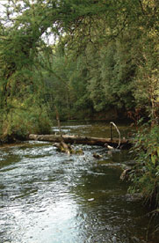
The TC Unit is home to 3 “Natural River” designated rivers: Upper Manistee, Boardman and Betsie Rivers. The Boardman and Betsie Rivers have their entire watercourse in the TC Unit. The Boardman and Manistee Rivers are both blue ribbon trout streams.

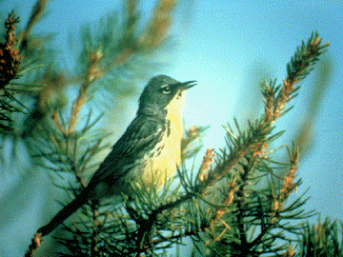
The unit has a variety of forest types ranging from rolling hardwood hills, oak, jack pine, red and white pine, aspen, conifer swamps and lowland hardwoods. Jack pine is the preferred species for the Kirtland’s Warbler, a federally listed endangered species. The TC Unit along with Wildlife Division manages a little over 10,000 acres in the eastern part of Kalkaska County for the Kirtland’s Warbler.
Photo: Richard Baetson,
U.S. Fish and Wildlife Service, Michigan, U.S.A.

Also in Kalkaska County’s east side, the Hansen Military Reserve and Military 20 year Lease Lands are used for military troop training purposes and affect approximately 42,500 acres of State land. Within the Hansen Military Reserve, the military owns the land and the DNR manages the timber. Twenty-year Lease Lands are parcels owned by the DNR and the military is free to train troops on that land.

One highlight of the unit is the Seven Bridges Natural Area located in Kalkaska County. Seven Bridges is best known for its rustic wooden bridges built at various sites cross the Rapid River and its adjacent tributaries. Rapid River is a blue ribbon trout stream and the Seven Bridges area has over one mile of river frontage. In 1882 a sawmill was built which dammed the river at Seven Bridges creating a holding pond for logs. Today the remains of the dam can still be seen when crossing the first three bridges. Since 1998, Seven Bridges has been owned by the Michigan Department of Natural Resources with the Grand Traverse Regional Land Conservancy being its primary caretaker. With help from the Kingsley Correctional Facility, the State replaced walkways and four of the bridges. Only four bridges exist today.
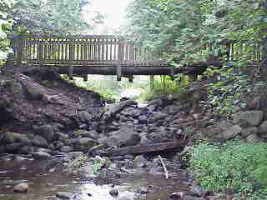
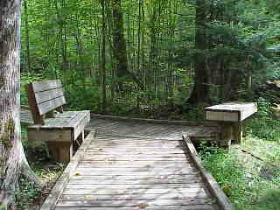

The 3,300 acre Skegemog Swamp Wildlife Area, located in Kalkaska County, has been called “One of the finest, most ecologically significant areas in the Lower Peninsula”. Another partnership with the Grand Traverse Regional Land Conservancy, Skegemog Swamp is home to herons, egrets, swamp songbirds, mink, otters, beavers, the secretive Massasauga rattlesnake and other wetland wildlife. Seven miles of shoreline on Skegemog Lake and Torch River provide critical habitat for many species of wildlife. A boardwalk provides visitors a chance to walk through a swamp without getting their feet wet. Two viewing platforms have been built to give visitors a better view of the area.

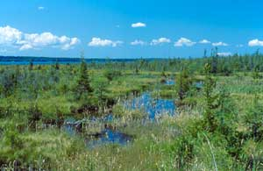
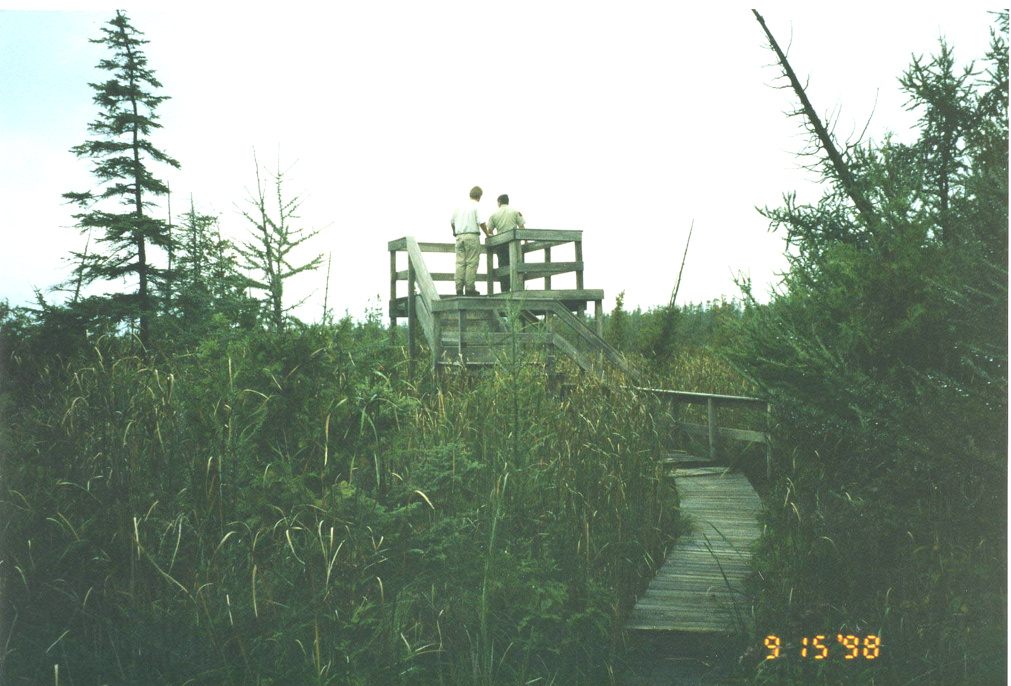
Photo: © Ray Rustem Photo: Dennis Vitton, MIDNR

The Sand Lakes Quiet Area was dedicated in 1973 by the Department of Natural Resources as a refuge from today’s noisy world. All motorized vehicles and equipment are prohibited from entering this area which makes it a great area to watch wildlife, hike, bike, or cross country ski. The 2,800 acres of State Forest land, located in Kalkaska and Grand Traverse Counties, provides an opportunity to enjoy the solitude of the forest environment. The rolling forested land with 5 marl lakes offers an interesting natural setting. There is a wide range of animal life and the lakes contain a variety of fish. An extensive trail system allows visitors to explore the lakes and surrounding area on foot, skis, bike, or horse. The Michigan Shore to Shore Riding and Hiking Trail (Lake Huron to Lake Michigan) skirts along the south end of the Quiet Area. Guernsey Lake State Forest Campground is available for hike-in campers.
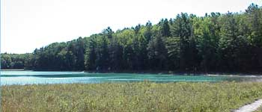
Photo: Mark Douglas, MIDNR

One of Michigan’s premier pathways is located on State land within the unit in Grand Traverse County. The 16.7 mile VASA Pathway, utilized by cross country skiers, mountain bikers, runners, walkers, and naturalists, features a series of loops and trails that offer both challenging and easier routes for every level of user. Managed under agreement with the Michigan Department of Natural Resources, Grand Traverse County, and TART Trails (Traverse Area Recreation Trail), the VASA Pathway is home to: North American VASA Ski Race, Grand Travers Classic, Women’s Ski Tour, The Iceman Cometh Challenge Bicycle Race and many high school racing events. The VASA Singletrack is one of the DNR’s only dedicated mountain bike pathways and is located within the VASA Pathway area and contains nearly 13 miles of single-track, bike trail.
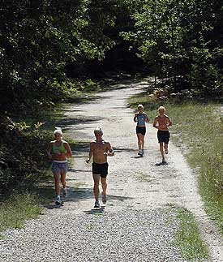
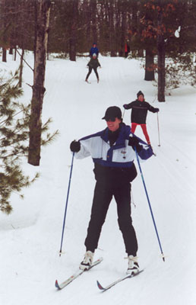
Photo: Bruce Bodjack
Springfield Parks and Recreation Area, located near Fife Lake in Kalkaska County, is an example of State and local cooperation to get a problem solved. In 1999 the State was going to block access into a beautiful overlook, Eagle View, on the Manistee River because of severe erosion and dumping problems. Springfield Township partnered with Adopt-A-Forest Program, local businesses and the TC Unit to clean up the site, build a platform and to restore Eagle View to its former beauty.
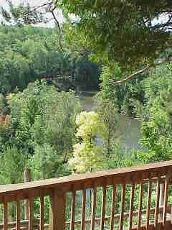
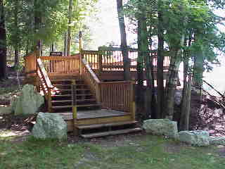
Photos: Gerald Grieve, MIDNR

