
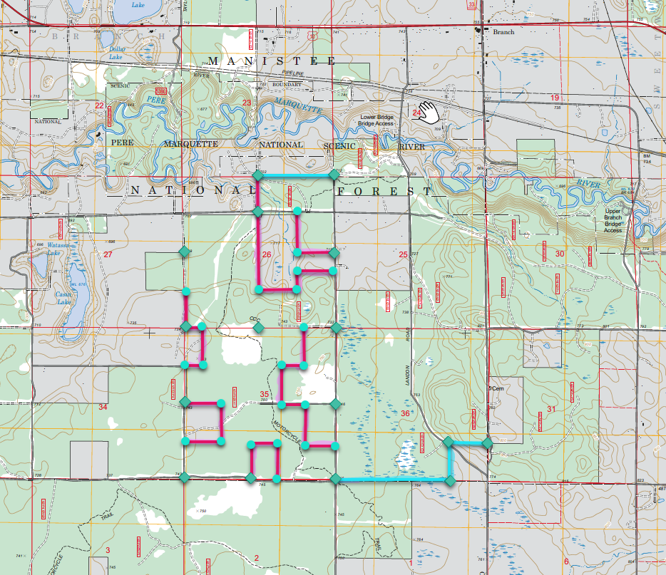

Legend
Control Corner
Corner To Monument
Line To Measure & Post
Line To Remark & Post

