**Great Lakes Culvert Inventory – How to update a site after a culvert replacement?**

*(v. 2/13/2023)*

Use the inbox function of Survey 123:

**Step 1:** Select Inbox from the Great Lakes Stream Crossings Survey 123 main menu.

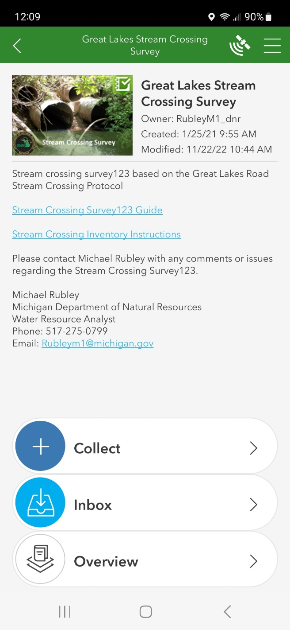

**Step 2:** Use the map to zoom into the location of the culvert replacement and select refresh. (This will download the crossing information to the device.)

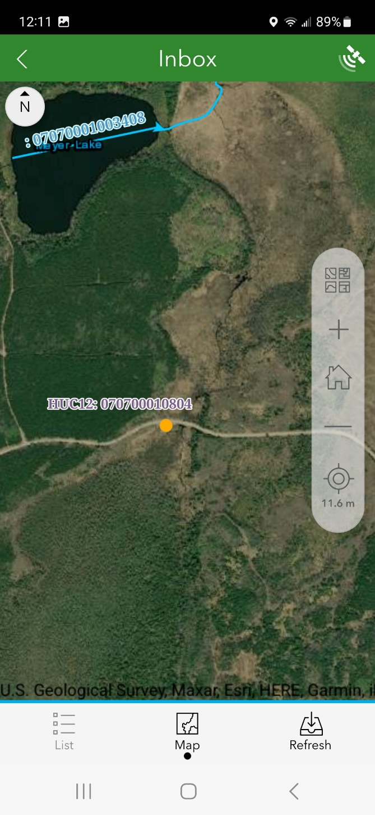

**Step 3:** Open the crossing to edit it.

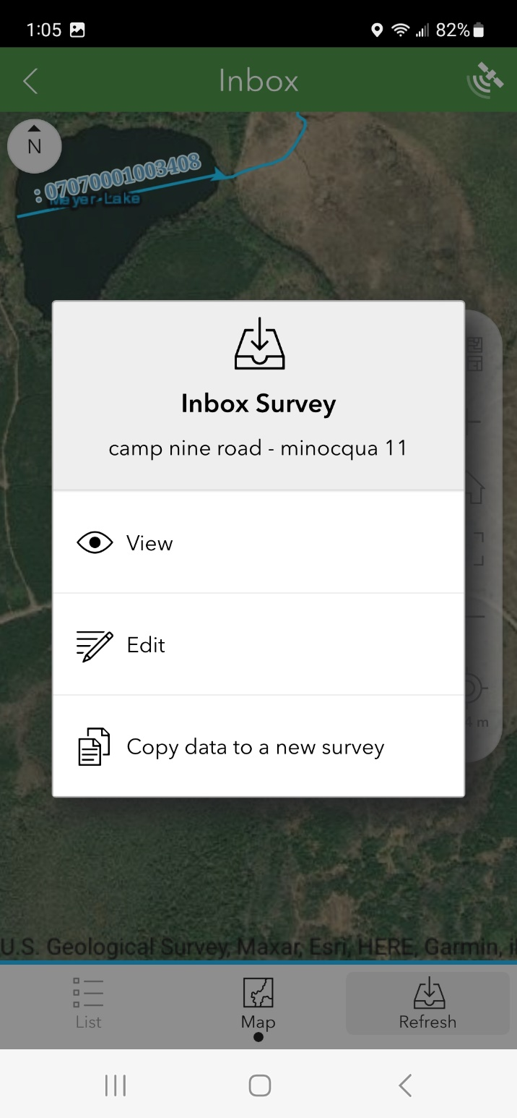

*Note: Crossings marked for removal or deletion are not removed from the database, only filtered out. This will allow the Great Lakes Culvert Inventory Team to create a separate view of the of the data, showing the active inventory (which is what people currently see) and historic inventories/replacements (a new visual data layer that will be available soon).*

**Step 4:** Select ‘Yes’ under Remove or Delete Site. Select ‘Crossing has been replaced’. Then update the appropriate data fields in the rest of the survey.

