Michigan Department of Natural Resources
Status of the Fishery Resource Report
No. 2005-1, Year 2005

OAKLAND LAKE
Oakland County (T3N, R9E, Sections 2, 3 and T4N, R9E, Sections 34, 35)
Surveyed May 2001

James T. Francis

Environment

Oakland Lake is a 255 acre lake located in central Oakland County, on the east side of Waterford in Waterford and Independence townships. There are several basins in the lake, reaching 25 feet, 27 feet, and the deepest being 64 feet (Figure 1), with all three basins having relatively steep side slopes. There are a number of shallow bays on the lake that are less than 5 feet deep and several small islands. The geology of the area surrounding the lake is characterized by sand and gravel glacial outwash. These areas are well drained and allow good infiltration to the ground water.

Oakland Lake is located on the upper reaches of the Clinton River watershed. The Clinton River enters Oakland Lake on the west end through a short, wide connection to Woodhull Lake immediately upstream. The Clinton River exits on the southeast end where there are two dams that regulate water level. Both Oakland and Woodhull lakes have a legal established lake level elevation of 957.43. A short distance downstream of Oakland Lake, the Clinton River enters into Loon Lake. Near the central portion of Oakland Lake and to the south, a short, shallow connection leads to Leggets Lake, which is a small (25 acres), shallow (10 feet) lake.

The water is characterized as clear, with good visibility (Secchi disk reading of 18 feet). Within the water column, alkalinity ranged from 154 ppm to 222 ppm and pH ranged from 7.22 to 8.50. Oakland Lake is deep enough that the water column stratifies annually. That means that during the summer, the lake develops three distinct water layers; the upper most layer, the epilimnion, is warm and well oxygenated; the middle layer or thermocline is intermediate in temperature and the amount of dissolved oxygen varies; the bottom layer, the hypolimnion, is cold and lacks oxygen. In July 2001, the thermocline was from 18 to 25 feet and was well oxygenated.

There is a public access boat launch on Oakland Lake, which also provides access to Woodhull and Leggets lakes via connecting channels. The shoreline of Oakland Lake is about 60% developed. Because of the large shoal areas, both emergent and submergent vegetation are abundant. The bottom type of Oakland Lake is organic material in the deep areas and sand and organic material in the shoal areas.

Much of the lake is man made because of the higher lake level created by the dams. The shallow bays and shoals have abundant aquatic plant growth which provide important fish habitat. Many of these shallow areas also had tree stumps. These stumps were present from when the surrounding low area was flooded by the installation of the dams and raising of the lake level. However, in 1987 the Oakland County Drain Commission was issued a permit to draw Oakland Lake down four feet to remove some of the tree stumps that were a safety concern for navigation and swimming. MDNR Fish Division worked with the Drain Commission Office to protect some stumps because of the important habitat they provide fishes. However, excessive stumps were removed, including ones that were designated to remain. Fisheries Division sought mitigation for the loss of fish habitat, but there are no records that the work was ever completed.

Fish habitat is also being altered by the use of chemical herbicides. A permit is required for pesticide application to surface waters of the state which are issued by the Michigan Department of Environmental Quality (DEQ). There were permits issued during 2003 and 2004, the two most recent years that data were available. In both 2003 and 2004, Oakland Lake was treated numerous times, primarily for control of algae, eurasian milfoil, and pondweeds. The treatment location and coverage area were dependent on the chemical used and the target plants. The largest area of coverage was 139 acres and 102 acres in 2003 and 2004, respectively. A request to use floridone, which is a whole lake treatment, was denied by DEQ in both 2003 and 2004.

Fishery Resource

A variety of gamefish species were stocked in Oakland Lake during the 1930’s and early 1940’s. Species stocked included bluegill, crappie, largemouth bass, smallmouth bass, yellow perch, and crayfish for forage. It is uncommon to stock these species today, as they are self sustaining and ubiquitous. Woodhull Lake has a similar stocking history, with the exception that it did not receive smallmouth bass. Woodhull Lake stocking information is mentioned because fish are able to move between the two lakes. Walleye were stocked in Oakland Lake in 1955, 1956, 1983, 1984, and 1986. The walleye stocking program was discontinued because a fishery failed to develop.

A record from 1944 made during the lake mapping indicated that there was a public fishing site and two boat liveries on Oakland Lake. Fishing was reported good for yellow perch, largemouth bass, and smallmouth bass, but bluegills, crappie, and pike were reported as small. At that time there was both summer and winter fishing on Oakland Lake. Today, Oakland Lake gets a fair amount of fishing pressure and is a popular bass fishing lake. There were 7 bass tournaments permitted in 2003 to be conducted at the public access site and 14 in 2004.

There were six fisheries surveys conducted on Oakland Lake between 1956 and 1994. A variety of gear was used in the surveys including fyke nets, trap nets, gill nets, and electrofishing, depending on the goal of the particular survey. The fish community in Oakland Lake during these earlier surveys was found to be composed primarily of panfish such as bluegill, yellow perch, rock bass, green sunfish, black crappie, longear sunfish, and pumpkinseeds. Predators included largemouth bass, northern pike, bullhead, bowfin, and gar. Growth data was limited for earlier surveys, but in the 1994 survey, most species were growing below the state averages.

The most recent fisheries survey was conducted on Oakland Lake in May 2001. Sampling included three standard trap nets that were tended daily and fished for three nights (9 net lifts), as well as day time electrofishing (Figure 1). The goal of the survey was to evaluate the current fish population and determine future management needs of the fishery.

A total of 18 fish species were collected during this survey, with 1,282 fish handled in total (Table 1a and 1b). Panfish such as bluegill, black crappie, green sunfish, pumpkinseed, rock bass, warmouth, and yellow perch comprised almost 87% of the total catch by number (trap nets and electrofishing combined) and 45% by weight. Predators such as largemouth bass, northern pike, bullheads, bowfin, channel catfish and walleye made up 10% of the catch by number and 30% by weight. Common carp accounted for 3% of the total catch by number, but 25% by weight.

Bluegill were the most abundant fish caught during this survey. They represented 68% of the total catch by number and 31% by weight (Table 1a and 1b). The bluegill in the trap net catch averaged 6.9 inches. The quality of the bluegill population in Oakland Lake was evaluated using Schneider’s Index. This index provides a relative measure of the quality of the bluegill fishery in a lake based on a scale of 1 to 7, with 7 being the best (Schneider 1990). Based on the trap net catch, the bluegill in Oakland Lake received an average to good rating (score 4.8). There was a good representation of ages in the catch, with fish ranging in age from 1 to 12 (Table 2). Overall, growth rates were about a half inch below the state average.

The next most abundant fish in the catch were black crappies. They accounted for 8% of the total catch by number and 8% by weight (Table 1a and 1b). The crappie averaged 8.9 inches long and were growing about 1 inch below the state average. Other panfish in the catch but in smaller numbers included pumpkinseeds, rock bass, yellow perch, green sunfish, and warmouth. Growth rates were about a half inch above the state average for pumpkinseeds, but well below the state average for yellow perch (Table 2).

Largemouth bass dominated the catch of larger gamefish during the survey, making up 4% of the total catch by number and 7% by weight (Table 1a and 1b). The bass averaged 11.5 inches long in the trap nets, with 20% of the catch exceeding the minimum size limit of 14 inches. Largemouth bass growth rates were slow; almost three inches below the statewide average (Table 2). It is unclear why growth rates are poor for largemouth bass, but long term growth data is not available to make comparisons.

Sixteen northern pike were caught, ranging in size from 13 to 30 inches; averaging 23.9 inches. All of the pike caught were growing well above the state average. Although the number of pike and largemouth caught may seem low, these species are not fully susceptible to the gear used because a general fisheries survey targets bluegill and other panfish. Although these surveys do not target larger game fish, attempts are made to catch an adequate sample to get a measure of abundance and growth. The catch rates of both bass and pike in this survey are good compared with other area lakes.

One walleye was caught in the survey, measuring over 29 inches long and weighing over 8 pounds. Dorsal spines were taken from this fish and it was aged to 10 years old. However, the older a fish gets, the harder it is to differentiate growth rings, which may result in under reporting the age of the fish. Even taking this into account, it is not likely that this fish was from the 1986 plant, which was the last plant to take place (fish would have been 15 years old). This fish may have been the result of rogue stocking. Sometimes anglers transport fish caught in one lake and relocate it to another. Regardless of the source, it is not common to see walleye this large in inland lakes and it is due to the older age this fish has attained.

Carp were a common catch in Oakland Lake. Although they made up only 3% of the total catch by number, they accounted for a quarter of the catch by weight (Table 1a). The disproportionate weight of the catch is due to the large size of the carp caught, ranging in length from 13 to 26 inches. Carp are a non-native species and compete with native fishes for food and space and have a negative impact on the environment. They feed in the sediments, often uprooting vegetation that is important habitat, and increasing turbidity.

A fish survey was conducted concurrently on the adjoining Woodhull Lake in 2001. The results of that survey are consistent with the findings on Oakland Lake (see Woodhull Lake 2001 Status of the Fishery Report). The catch rates and size structure of the fish community were very similar between the two lakes. The growth rates were also the same; below average for bluegill, black crappie, yellow perch, and above average for pumpkinseeds. Largemouth bass were very slow growing in both lakes; conversely, northern pike were very fast growing. During the survey, fish were observed traveling and nesting in the wide connection between the two lakes. The short, unobstructed connection and similarity in the fish communities support that these two lakes can be managed as one water body.

Management Direction

Overall, there is a good fish community in Oakland Lake. Bluegill and other panfish are abundant with a good size structure and a good balance of larger game fish. Largemouth bass are present in good numbers, although their growth rates are below ideal. Pike are also present in good numbers and have good growth rates. Northern pike require emergent vegetation in shallow marsh areas for spawning. Unfortunately, this habitat is at risk in many lakes in southeast Michigan due to dredging, seawall construction, and other shoreline development. Marsh areas and emergent vegetation should be protected on Oakland Lake, and the connected Woodhull Lake, because it provides critical habitat for northern pike and other wildlife. Because northern pike are a top predator, they serve an important ecological function to provide balance to the entire fish community. Loss of pike from Oakland Lake would result in a decline in the quality of the panfish fishery.

Aquatic plant management has to be done responsibly. Aquatic plants provide important habitat for fishes and other aquatic organisms. Plants provide cover for small fishes and juvenile game fishes and also support invertebrates which are an important food source. However, some plant species, such as eurasian milfoil can cause problems. Eurasian milfoil is an exotic species that forms dense mats that can displace native plant species. Therefore, reducing eurasian milfoil can benefit the plant and fish community in a lake. However, over-application of chemicals or using non-specific chemicals can harm the native plant community which is important to fishes. Therefore, it is important that chemical control of aquatic plants be regulated and results monitored.

Redear sunfish would be a good addition to the fishery and appear to be a good candidate for Oakland Lake. Redears have been established successfully in southern Michigan to provide a trophy panfish opportunity for anglers (Towns 2003). Redear sunfish grow faster than either bluegill or pumpkinseeds, and attain a larger size. Redears reach a length of almost 9 inches by age 5, where a bluegill takes about 10 years to reach a similar size. Most lakes where redears have been established produce redear sunfish greater than 10 inches long (Towns 2003). Redears are similar to pumpkinseeds and do well in lakes that have large areas of marl. The fact that pumpkinseeds have an above average growth rate further supports the potential for a successful redear program. Stocking is recommended for a three year period, at which point redears are usually self sustaining.

Report completed March 4, 2005

References

Schneider, J. C. 1990. Classifying bluegill populations from lake survey data. Michigan Department of Natural Resources, Fisheries Division Technical Report 90-10, Ann Arbor.

Towns, G. L. 2003. Redear sunfish management in Michigan. Michigan Department of Natural Resources, Fisheries Division Technical Report 2003-3, Ann Arbor.

Table 1a.-Number, weight, and length indices of fish collected from Oakland Lake with trap nets, May 7-10, 2001.

Species | Number | Percent by Number | Weight (pounds) | Percent by Weight | Length range (inches)¹ | Average length | Percent legal size²
Panfish
Bluegill | 707 | 66.3 | 165.8 | 31.1 | 4-9 | 6.9 | 87.7
Black crappie | 107 | 10.0 | 43.7 | 8.2 | 6-11 | 8.9 | 96.3
Pumpkinseed | 74 | 6.9 | 20.1 | 3.8 | 5-7 | 6.8 | 91.9
Rock bass | 25 | 2.4 | 8.4 | 1.6 | 5-9 | 7.5 | 84.0
Warmouth | 1 | 0.1 | 0.1 | <0.1 | 5 | 5 | 0
Yellow perch | 1 | 0.1 | 0.2 | <0.1 | 7 | 7 | 100
Predators
Brown bullhead | 51 | 4.8 | 29.2 | 5.5 | 8-12 | 10.6 | 100
Largemouth bass | 43 | 4.0 | 38.4 | 7.2 | 7-17 | 11.5 | 18.6
Northern pike | 16 | 1.5 | 53.2 | 10.0 | 13-30 | 23.9 | 63.5
Bowfin | 6 | 0.6 | 27.5 | 5.2 | 21-26 | 23.3 | --
Channel catfish | 1 | 0.1 | 1.1 | 0.2 | 14 | 14 | 100
Walleye | 1 | 0.1 | 8.5 | 1.6 | 29 | 29 | 100
Others
Common carp | 33 | 3.1 | 137.3 | 25.7 | 13-26 | 20.3 | --

¹Note: some fish were measured to 0.1 inch, others to inch group: e.g., “5”=5.0 to 5.9 inches; “12”=12.0 to 12.9 inches; etc.
²Percent legal size or acceptable size for angling

Table 1b.-Number, weight, and length indices of fish collected from Oakland Lake by electrofishing, May 18, 2001.

Species | Number | Percent by Number | Weight (pounds) | Percent by Weight | Length range (inches)¹ | Average length | Percent legal size²
Panfish
Bluegill | 160 | 74.1 | 5.5 | 38.3 | 1-7 | 3.5 | 1.9
Pumpkinseed | 14 | 6.5 | 1.6 | 11.1 | 3-6 | 5.1 | 14.3
Hybrid sunfish | 13 | 6.0 | 0.2 | 1.5 | 2-3 | 2.9 | 0
Yellow perch | 5 | 2.3 | 0.4 | 2.6 | 5-6 | 5.7 | 0
Green sunfish | 1 | 0.5 | 0.1 | 0.8 | 5 | 5 | 0
Rock bass | 1 | 0.5 | <0.1 | 0.1 | 2 | 2 | 0
Predators
Largemouth bass | 8 | 3.7 | 1.9 | 13.5 | 4-11 | 7.3 | 0
Yellow bullhead | 4 | 1.9 | 1.4 | 9.8 | 8-9 | 9.0 | 100
Grass pickerel | 2 | 0.9 | 0.1 | 0.9 | 6-7 | 7.0 | --
Bowfin | 1 | 0.5 | 3.1 | 21.2 | 20 | 20 | --
Others
Bluntnose minnow | 7 | 3.2 | <0.1 | 0.2 | 2-3 | 2.4 | --

Table 2.-Average total length (inches) at age, and growth relative to the state averages for six species of fish sampled from Oakland Lake, May 7-10, 2001.

Species | Age group | Number of fish | Length range (inches) | Mean Length | State average length | Growth index | Mean growth index¹
Black crappie |  |  |  |  |  |  | -0.9
 | III | 1 | 7.0 | 7.0 | 7.5 | --
 | IV | 13 | 6.2-8.4 | 7.5 | 8.6 | -1.1
 | V | 31 | 7.6-10.7 | 9.1 | 9.4 | -0.3
 | VI | 8 | 6.4-10.3 | 9.0 | 10.2 | -1.2
 | VII | 4 | 10.8-11.7 | 11.1 | 10.8 | --
 | VIII | 5 | 9.8-11.5 | 10.4 | 11.4 | -1.0
 | X | 1 | 10.1 | 10.1 | -- | --
Bluegill |  |  |  |  |  |  | -0.6
 | I | 6 | 1.5-2.1 | 1.8 | 1.8 | 0
 | II | 10 | 2.3-3.3 | 2.7 | 3.8 | -1.1
 | III | 8 | 3.7-4.5 | 3.9 | 5.0 | -1.1
 | IV | 19 | 3.8-5.7 | 4.7 | 5.9 | -1.2
 | V | 17 | 4.9-7.2 | 5.9 | 6.7 | -0.8
 | VI | 15 | 5.8-8.2 | 7.1 | 7.3 | -0.2
 | VII | 8 | 6.6-8.8 | 7.3 | 7.8 | -0.5
 | VIII | 8 | 7.7-9.1 | 8.1 | 8.2 | -0.2
 | IX | 2 | 8.0-8.4 | 8.2 | 8.6 | --
 | X | 1 | 8.1 | 8.1 | 8.9 | --
 | XII | 1 | 8.2 | 8.2 | -- | --
Largemouth bass |  |  |  |  |  |  | -2.7
 | II | 2 | 4.1-5.4 | 4.8 | 7.1 | --
 | III | 9 | 5.1-9.2 | 7.3 | 9.4 | -2.1
 | IV | 9 | 8.0-10.2 | 9.4 | 11.6 | -2.2
 | V | 9 | 9.8-12.6 | 11.0 | 13.2 | -2.2
 | VI | 7 | 10.3-14.6 | 12.3 | 14.7 | -2.4
 | VII | 5 | 11.6-14.2 | 12.6 | 16.3 | -3.7
 | VIII | 6 | 12.6-17.5 | 14.0 | 17.4 | -3.4
 | IX | 1 | 15.4 | 15.4 | 18.3 | --
 | X | 2 | 14.4-14.9 | 14.7 | 19.3 | --
 | XI | 1 | 16.0 | 16.0 | -- | --
Northern pike |  |  |  |  |  |  | +3.7
 | I | 1 | 13.1 | 13.1 | 11.7 | --
 | II | 1 | 13.0 | 13.0 | 17.7 | --
 | III | 12 | 21.2-28.2 | 24.5 | 20.8 | 3.7
 | IV | 1 | 29.2 | 29.2 | 23.4 | --
 | X | 1 | 30.1 | 30.1 | -- | --
Table 2.-Continued

Pumpkinseed |  |  |  |  |  |  | +0.4
 | II | 3 | 3.4-3.6 | 3.5 | 3.8 | --
 | III | 6 | 5.0-5.8 | 5.5 | 4.9 | 0.5
 | IV | 5 | 4.5-6.2 | 5.3 | 5.6 | -0.3
 | V | 21 | 5.8-7.5 | 6.8 | 6.2 | 0.6
 | VI | 7 | 6.7-7.6 | 7.2 | 6.6 | 0.6
 | VIII | 3 | 7.1-7.9 | 7.4 | 7.5 | --
Yellow perch |  |  |  |  |  |  | --
 | II | 1 | 5.3 | 5.3 | 5.2 | --
 | IV | 1 | 5.7 | 5.7 | 7.5 | --
 | V | 1 | 5.9 | 5.9 | 8.5 | --
 | VI | 2 | 5.6-6.5 | 6.1 | 9.4 | --
 | VII | 1 | 7.9 | 7.9 | 10.3 | --

¹Mean growth index is the average deviation from the state average length at age. A minimum sample size of five fish is required to calculate a growth index.

Figure 1.-Map of Oakland Lake with sampling locations.
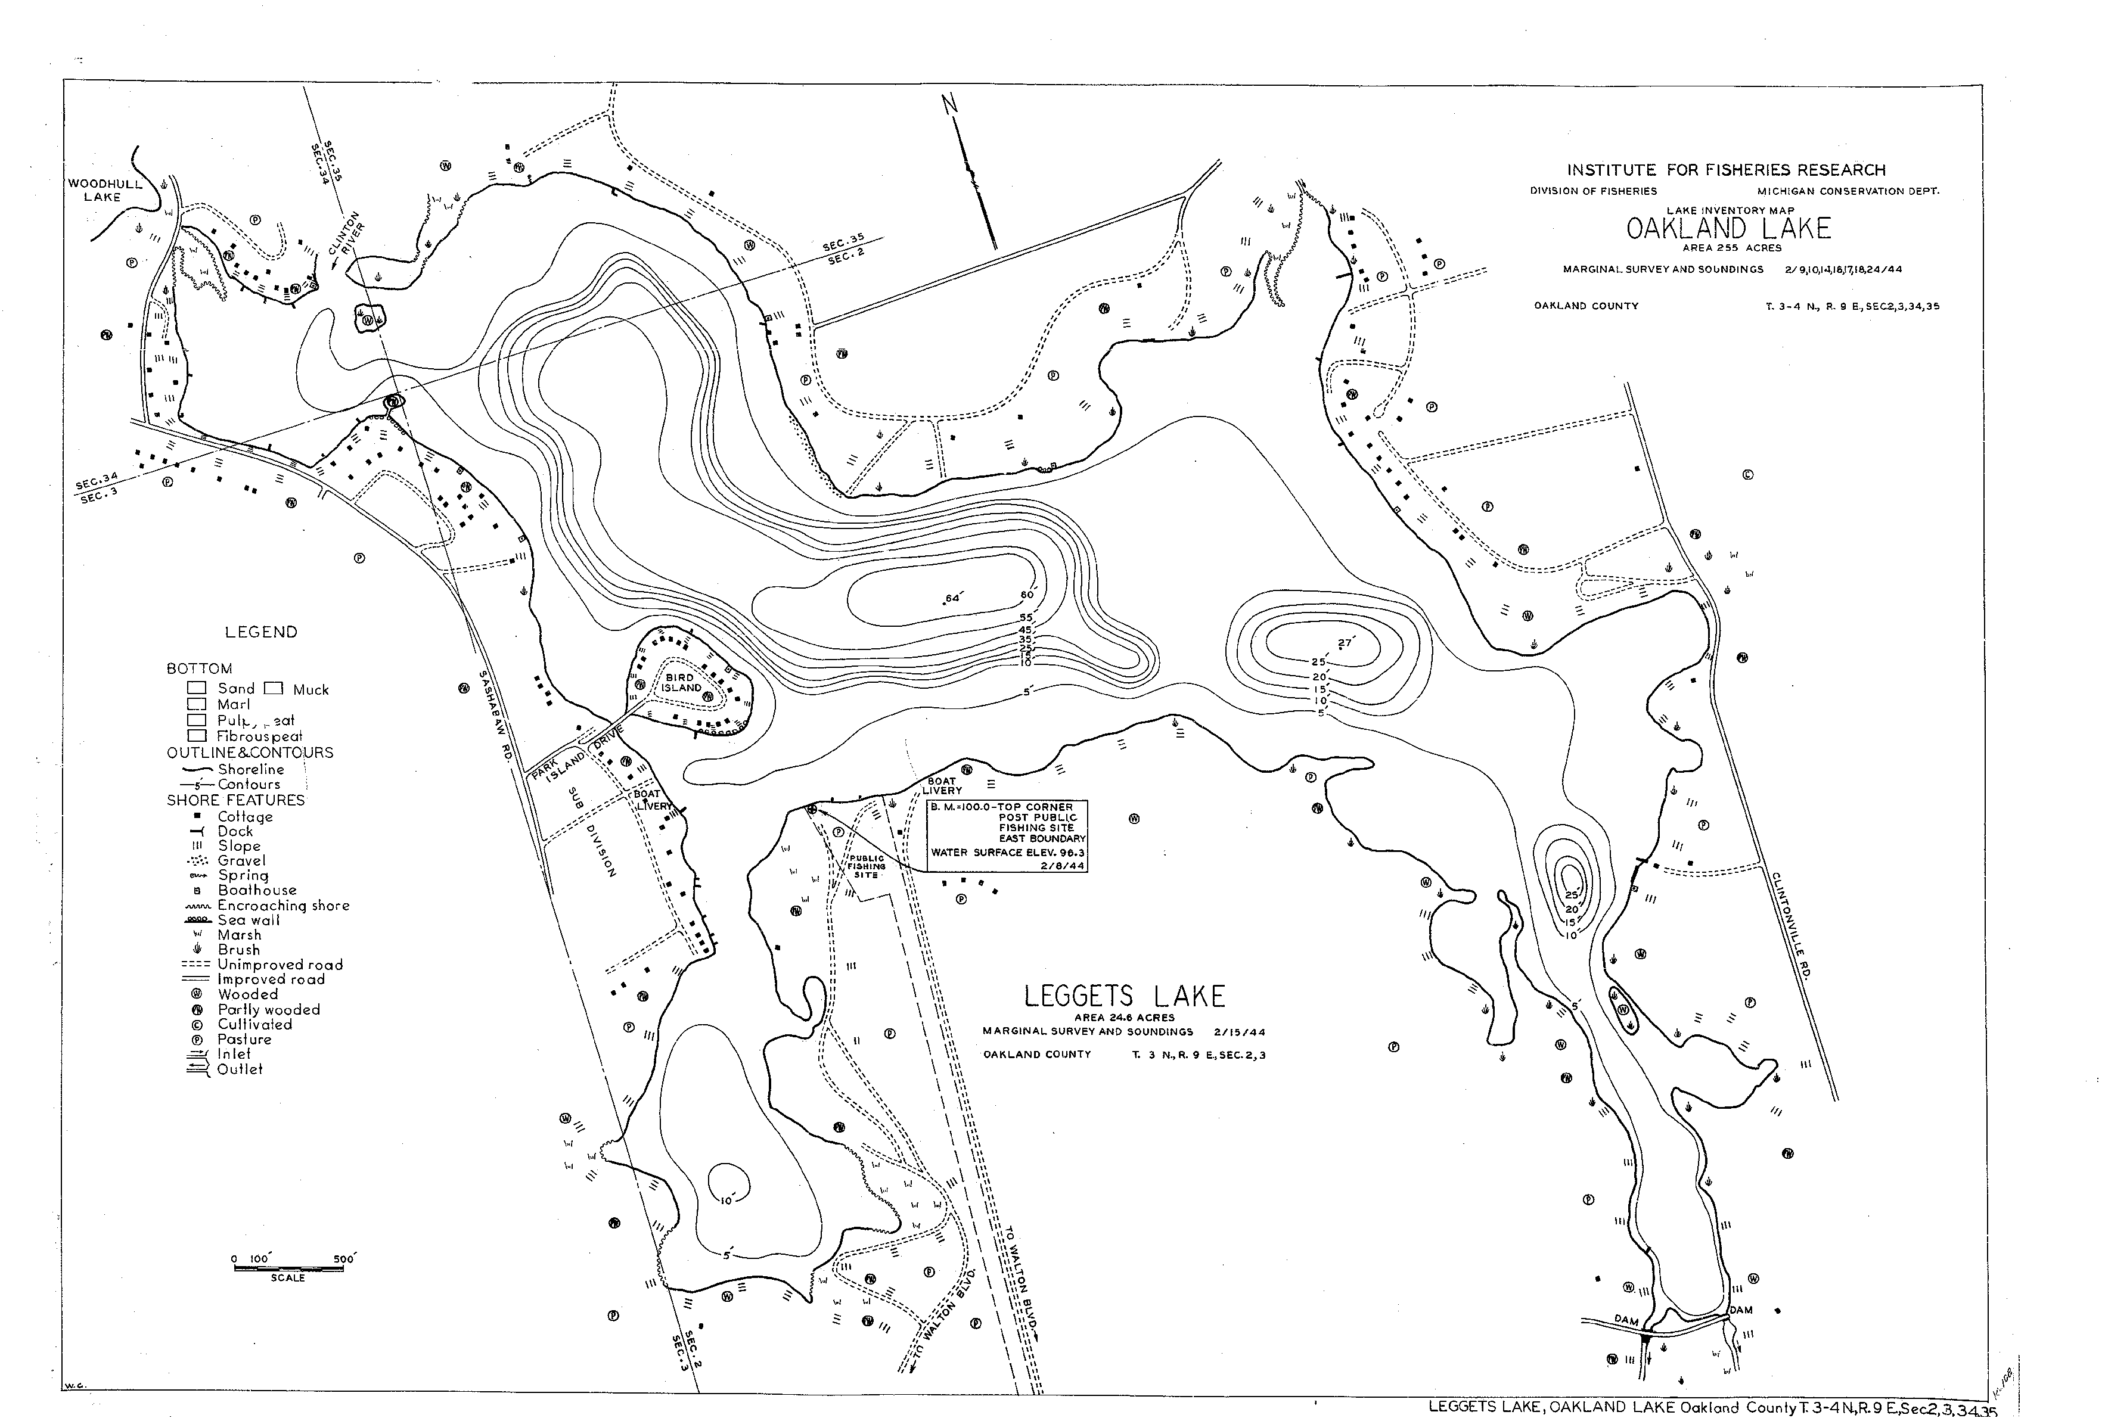
Trap net location
Electrofishing location

